SPONSORSHIP BUDGET PROPOSAL 2021

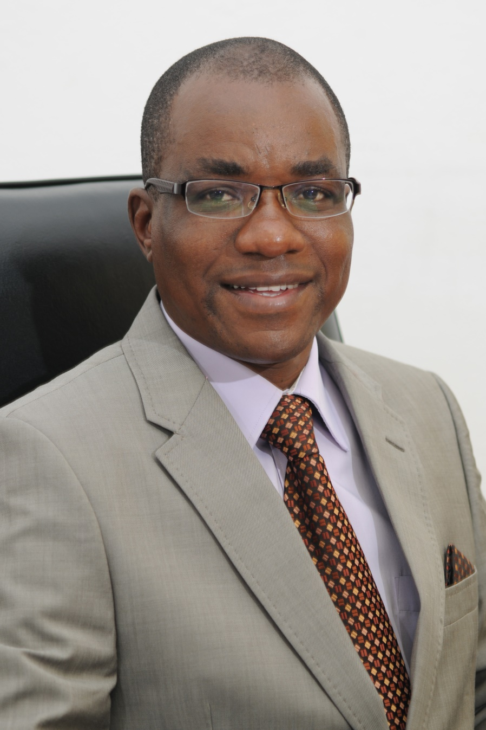
Professor Eddie Mwenje
Vice Chancellor – Bindura University of Science Education
Through his vision and passion the university finally made the concept of the National Sports Academy a reality in 2013. This followed the mandate given to Bindura University of Science Education by the Government of the Republic of Zimbabwe, to host this important national project. The university is grateful to Professor Mwenje’s visionary leadership and stewardship. The current achievements by the National Sports Academy, are indeed a testimony of this. His support for this new national project has been phenomenal.

SAMMARY OF ACHIEVEMENTS BY THE NATIONAL SPORTS ACADEMY TALENTEES
Bindura University of Science Education was given the mandate to house the National Sports Academy by Government in 2006. Due to the economic down turn experienced from 2006-2012 not much movement was seen in respect of making this a reality. However, in 2013 the University took a deliberate attempt at resuscitating the idea with full support from the Ministry of Higher and Tertiary Education, Science and Technology Development. To date a lot of movement and positives have taken place, among them, the recruitment of staff to initiate programmes and activities, identification and recruitment of talentees in prioritized sports and the facilitation of infrastructural development by the Ministry of Youth Sport Arts and Recreation who is now sponsoring the project. The Academy embarked on a massive talent identification programme that has born fantastic results in some of the National, Regional, Africa and International championships.
SUCCESSES SCORED BY THE NATIONAL SPORTS ACADEMY TALENTEES 2013 - 2019
- Embarked on a massive talent identification programme that has born fantastic results. When the Academy started in 2013, there were only three (3) talentees, one boy and two girls. However, the number has risen to fifty-four (54) in the following sporting disciplines; Athletics, Football, Chess, Judo, Boxing and Golf. Out of the fifty-four (54) twenty-five (25) of them are resident in Bindura.

- IN 2013 three (3) talentees immediately started representing the University and the country in international championships. In 2013 Enlitha Ncube participated in the World Junior Championships in 2013 in United States where she performed very well while Maryjoy Mudyiravanji also participated in the World Junior Championships in 2013 in Ukraine. That was the beginning of greater things to come in the future.

- In 2014, Titus Nyati, Maryjoy Mudyiravanji and Enlitha Ncube participated in the Youth Olympics which took place in Nanjing, China where Maryjoy came 6th in 800m in these Olympics.

- The talentees continued to excel in their sporting activities when two female talentees participated in the World Junior Championships held in Cali in Colombia in 2016. These were Nomatter Kapfunzaruwa and Enlitha Ncube.

- April 2017, our talentees participated in the Southern Africa Junior Championships held in South Africa where two of our talentees qualified for the World Junior Championships which held in Finland in July 2018.

- In the following month (May 2017), our talentees also participated in the Southern Africa Junior Championships held in Botswana where another two talentees qualified for the World Junior Championships to be held in Finland in July 2018.

- Six of our talentees participated in the World Junior Championships held in Algeria in 2018 where they acquitted themselves very well.

- Team Zimbabwe comprising 5 athletes and a coach participated in the World Relays Championships which took place in July 2019 in Yokohama, Japan. The National Sports Academy was represented by Dickson Kapandura.

- Leon Tafirenyika, one of our talentees in 2.1 doing Peace and Governance with Bindura University of Science Education, participated in the World Student University Games (FISU) which took place in Italy in July 2019. He was the sole representative of the Zimbabwe Universities athletes at the Finals. Leon performed well in the heats and qualified for the semi-finals. Unfortunately he pulled a hamstring during the semi-finals and he couldn’t finish the race.

- In February 2019, ten (10) talentees received the Vice Chancellor’s Achievement Awards held at the Zimbabwe Olympic Committee Offices in Harare. This was in recognition of the excellent performance by the talentees at regional competitions that included the Region 5 Youth Games held in Botswana in 2018. Each talentee got blazer at the colourful ceremony.

- On the local scene, the talentees continue to dominate the competitions. In March 2019, nine (9) of the talentees, participated in the National Association of Secondary School Heads (NASH) Mashonaland Central Athletics Finals in Chiweshe and scoped 33 medals out of the 44 medals Bindura District won. Twenty-two (22) were gold medals, six (6) silver and five (5) bronze. These talentees qualified for the NASH National Finals in Gweru (March 2019) where they scoped ten (10) gold and two (2) silver medals for Mashonaland Central province. Three (3) talentees qualified to take part in the Confederation of School Sports Association of Southern Africa (COSSASA) finals held in Eswethini in May 2019 where Paul Marandu got a silver in Javelin and Lynnette Zembe came 4th in 200m. Eight countries participated in these finals.

- In March 2019, fourteen (14) of our talentees participated in the JM Busha 54 1st Leg Athletics Championships held at the White City Stadium n Bulawayo. The talentees got nine (9) gold, three (3) silver and two (2) bronze. This qualified them to participate in the 2nd Leg of the competition held at Mutare Boys High on 20 April 2019 where they also performed very well coming up with ten (10) gold, six (6) silver and two (2) bronze. This also qualified hem to compete in the 3rd and Final leg of the competitions held in June 2019.

- In April 2019, the 14 talentees also participated in the University of Zimbabwe Track and Field. The talentees scoped fifteen (15) gold, four (4) silver and two (2) bronze. Dickson Kapandura broke his personal best record in 400m in 47.13s and Brian Ndlovu also created a new national record in High Jump with a height of 2.11m

- In April 2019, sixteen (16) Team Zimbabwe Athletics participated in the Botswana International Invitation. Five of our talentees were part of Team Zimbabwe that took part in these championships. Maryjoy Mudyiravanji, got a bronze in 1500m while Dorothy Kavhumbura and Dickson Kapandura got bronze each in 4 x 100m race.

- Botswana International Meet which took place in March 2019 saw Team Zimbabwe Relay scoping a gold medal. Dickson Kapandura, one of the Academy talentees, was part of the relay team members. The times the team posted in this competition saw the Zimbabwe Relay team being ranked 1st in Africa and 2nd in the world after Jamaica. The team broke a 12 year record of 39,16s set in 2007 at the All Africa Games in Algiers, Algeria. The team qualified to take part in the World Relays in Yokohama, Japan.

- In April 2019, Privillege Chikara (1500m) and Dorothy Kavhumbura (200m and Triple Jump) participated in the Confederation of Africa Athletics (CAA) Junior Athletics Championships hosted by Cote D’Ivoire. Privillege came 6th in her race while Dorothy picked a bronze in Triple Jump.

- Our three Chess talentees competed in the Africa Individual Schools Chess Championships hosted by Zimbabwe in 2017 and performed very well. One came 4th, the other came 7th and the third came 14th in their various age groups. The three qualified to represent Africa in Albania during World Individual Schools Chess Championships in 2018

- The Academy is also proud to have one talentee in Golf, Danaishe Matimba who have proved to be one of the best Golfers of her age.

- Our talentees also continue to excel in their educational programmes with one of these talentees is now in Part 3.1 - Peace and Governance at Bindura University of Science Education. The Academy is expecting four (4) more to join Prosper Mazuva.

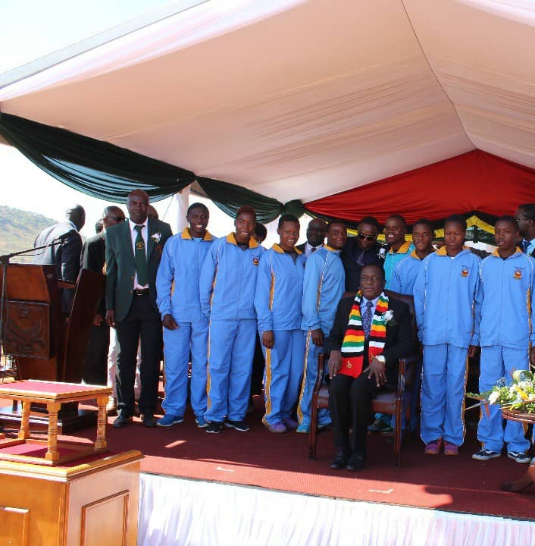
In recognition of these sterling performances as well as the 2018 achievements the Vice Chancellor hosted an Awards Ceremony on Friday, 1 February 2019 at the Zimbabwe Olympic Committee Headquarters.

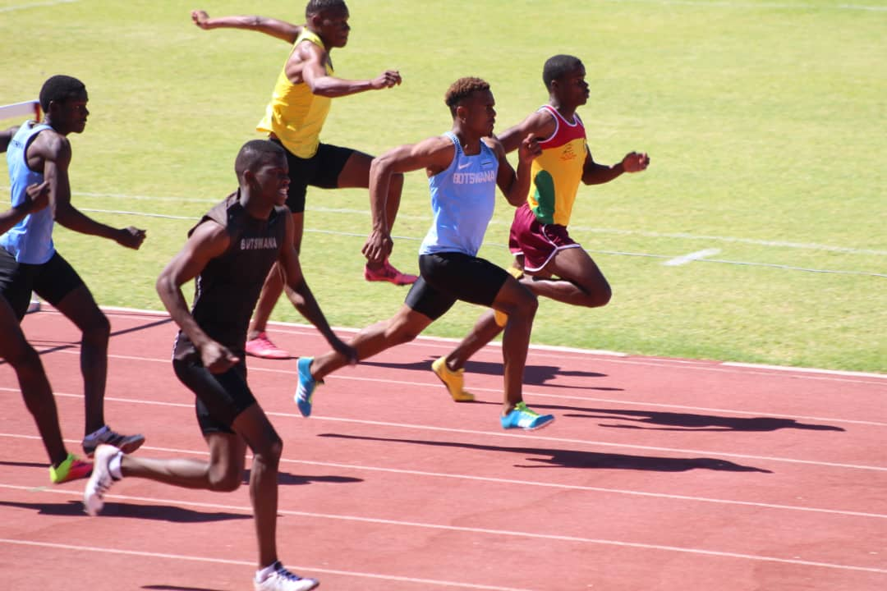
Norman Mukwada (orange t-shirt and purple shorts) – leading in the 400m/h race in Botswana. This qualified him to take part in the World Junior Championships in Tempere, Finland which took place in July 2018.
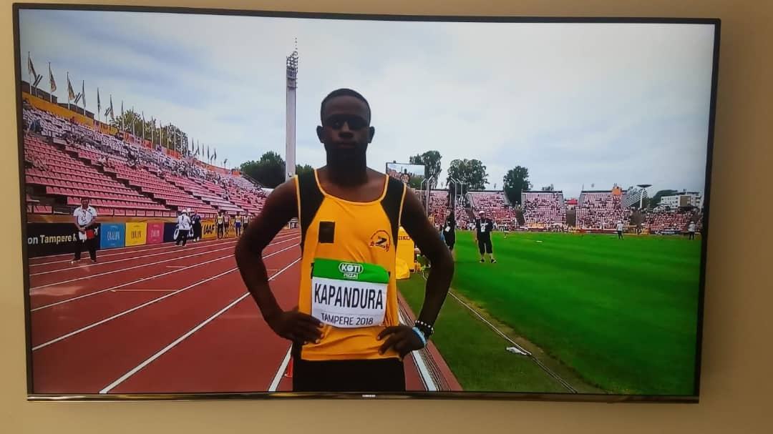
Dickson Kapandura in Morocco for the Africa Union Games 2019.
AFRICA GAMES- CASABLANCA MOROCCO
Five of our talentees qualified to participate in the 2019 edition of the Africa Games held in Casablanca, Morocco from 19 to 31 August 2019. These are:
Nyasha Mutsetse, Kapandura Dickson, Kavumbura Dorothy, Norman Mukwada,
Leon Tafirenyika

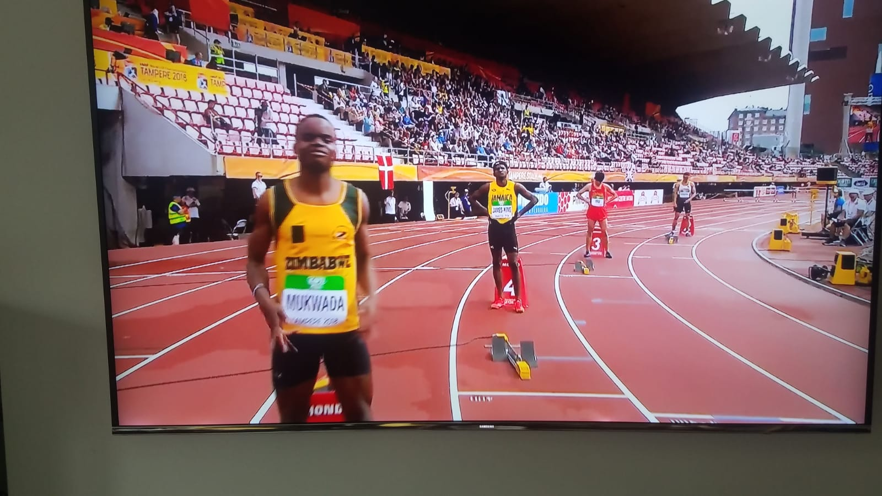
Norman Mukwada, ready for his 400m hurdle race in Finland 2019

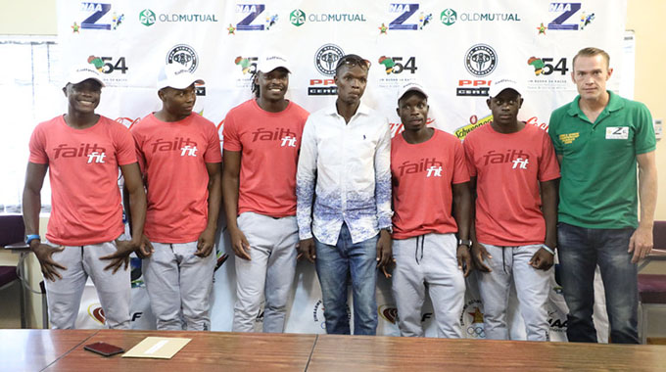
The team: Dickson Kamungeremu, Tatenda Tsumba, Itayi Vambe, Ngoni Makusha, Dickson Kapandura - National Sports Academy talentees. Their coach was David Tinago. One of the sponsors is in a green t-shirt.
This is the first time Zimbabwe participated at the World Relay Championships and the team’s success which broke a 12-year national record excited everyone The team ran 38,95 seconds in Gaborone, Botswana to qualify for the first time

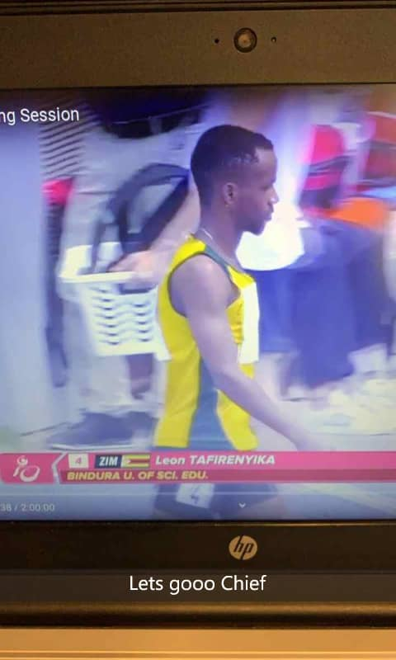
Leon Tafirenyika during the STUDENT WORLD UNIVERSITY GAMES in Napoli in 2019
One of our talentees Leon Tafirenyika, a 2.1 student in Peace and Governance, participated in the 2019 World University Games - FISU held in Napoli, Italy. Leon ran in the 200 m race and 400m race qualified for the semi-finals after clocking 21: 42s. and 47:07 seconds respectively.
Summary of Performances
NAME | EVENT | PERFORMANCE
Linnet Zembe | 100 m  200 m  800 m  Long jump | 13.31 s  5.1 m
David Nyamufarira | 800m  100m  200m | Personal Best 12.00
Paul Marandu | Javelin | 56,65m
Wayne Nkomo | Javelin | 45.09m
Wayne Nkomo | Shot putt | 11.55m
Sharon Mhembere | 400 m  200m | 58.98s  25.78s
Danai Matimbe | Golf H/P | 7 (19) Hand cap
Brian Ndlovu | High Jump | 2.10m Personal Best in Algeria  2.02m Silver in Botswana
Norman Mukwada | 400 m / hurdles  110m / hurdles  400m | 50.79s*National Record U20 Gold in Botswana  14,47s Gold in Botswana  47,58s
Dickson Kapandura | 260m  100m | 21.43s Silver in Botswana  10.66s Silver in Botswana
James Mtenje | Javelin | 59.06m Gold in Botswana
Dorothy Kavumbura | 100m  Triple Jump | 12.88.5s  Gold in Botswana
Vanessa Matimbe | 400m | 59.38.2 Bronze in Botswana
Dickson Kapandura, Brian Ndlovu,  Mukhokeli Sibanda, Norman Mukwada | 4x400 m | 3.12.89 Bronze in Botswana
Dickson Kapandura, Brian Ndlovu  Mukhokeli Sibanda, Norman Mukwada | 4x100 m | 41.80s Silver in Botswana
Privilege Chikara | 800 m  1 500 m  Cross Country | - 2m.11s  - 4m.43s (4th in Botswana)  - 5th in Algeria at the Africa Championship  - 12th in the World at the Youth Olympic games in Argentina  - 22nd in the World at the Youth Olympic games in Argentina
Vanessa Matimbe | 400m | - 59.38.2 Bronze in Botswana

BUDGET FOR SPONSORSHIP
Item | Description | Unit Cost  (US$) | Total Cost  (US$) | Total Cost @  1:85 RTGS
1 | Branded Sporting Kit (competition & training kit) (30 talentees X two sets each person per year) | 588.00 | 35 280.00 | 2 998 800.00
2a | Educational Scholarship for  (19 talentees - Chipindura High) | 9 050.00  (Per term X 3) | 20 634.00 | 1 753 890.00
2c | (5 talentees - Buse) | 27 000.00 rtgs | 1 588.00 | 135 000.00
3 | Sporting Equipment |  | 30 000.00 | 2 550 000.00
 | TOTAL |  |  | 7 437 690.00

